Simple Passing
Category: Technical: Passing & Receiving Difficulty: Beginner
Partner Passing (10 mins)
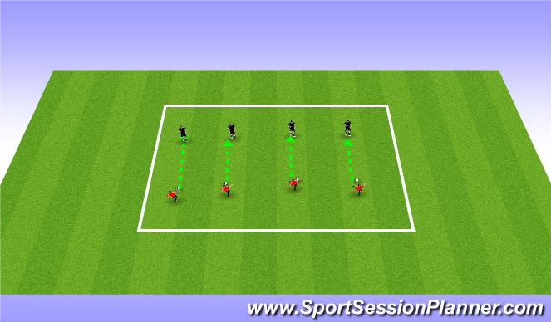
Players work in pairs.
Technique:
Inside of foot (push Pass)
Top of foot (laces pass)
Paint the square (15 mins)
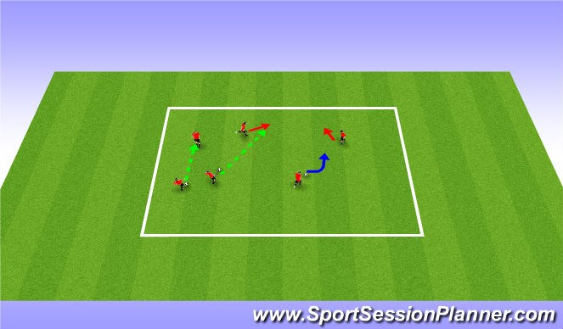
Paint The Square:
Players pass the ball in the square to move the ball all four sides of the grid
CP:
Encourage the ball to be played in front of the partner so they can receive the ball in motion
*if their on the line of the square have them play with hips open to field to receive the ball
Pass accuracy (15 mins)
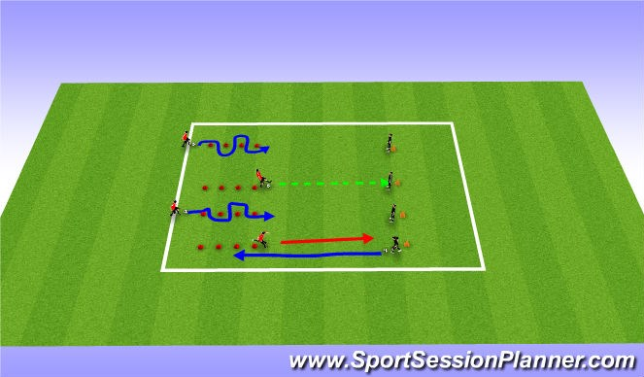
Blue = dribble Green= pass
Red = Run
Players dribble through Cones and pass to partner, Partner who receives the pass dribbles down to cones and dribbles through

Encourage proper technique and quality of pass to target

This may also be done in free space. Their dribbling through cones is to help them get comfortable with using all parts of their feet.

2v2 1 pass (15 mins)
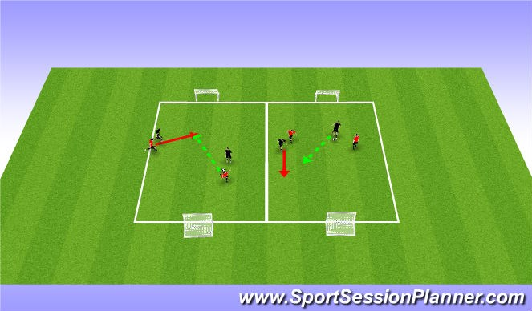
Players Play 2v2 coach will Restrict the players to complete a pass before scoring.

